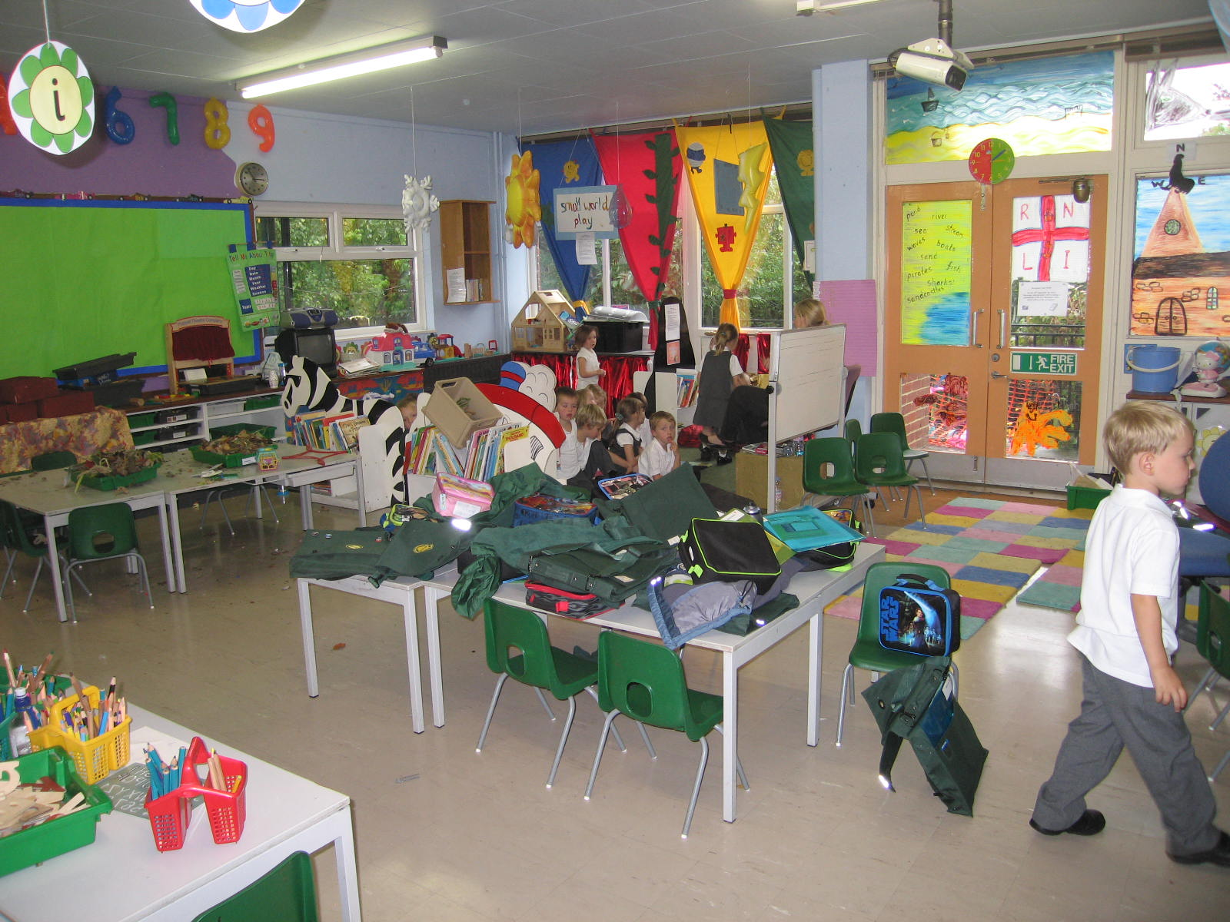

**Reception Class**

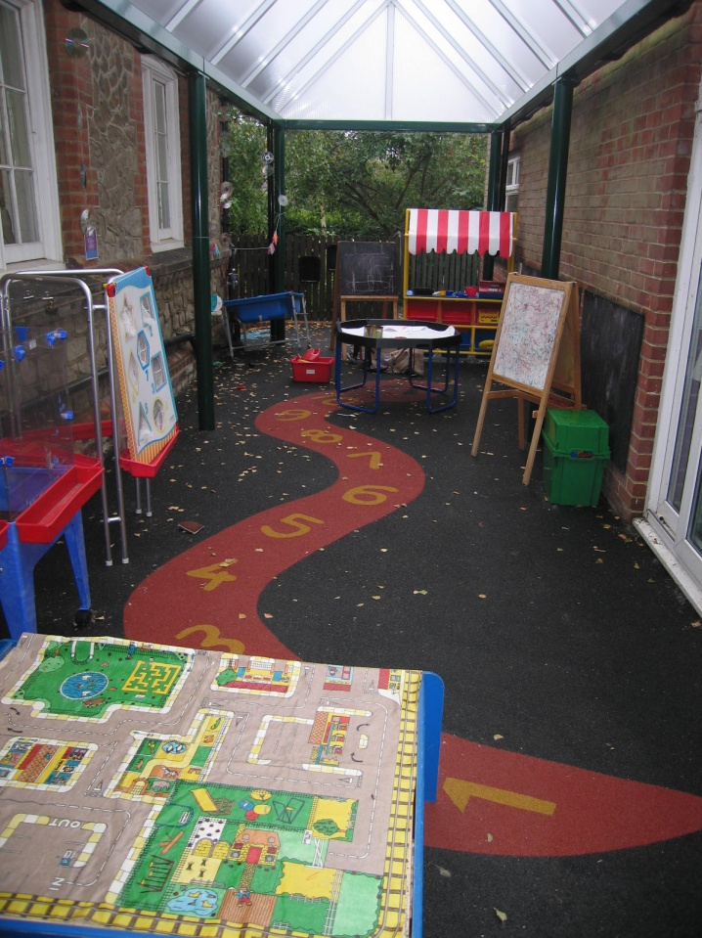

**Reception outside area**

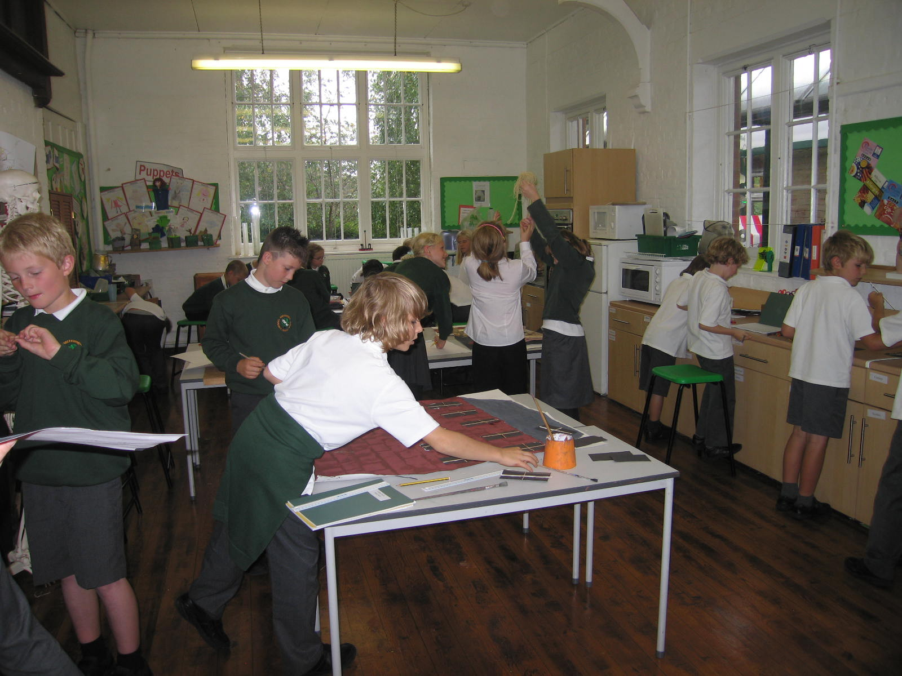

**Technology Room**

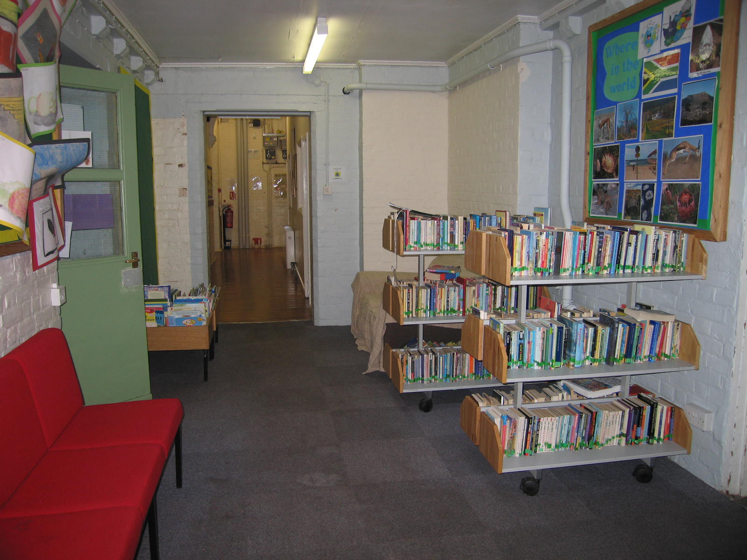

**Fiction Library and Reading Area**

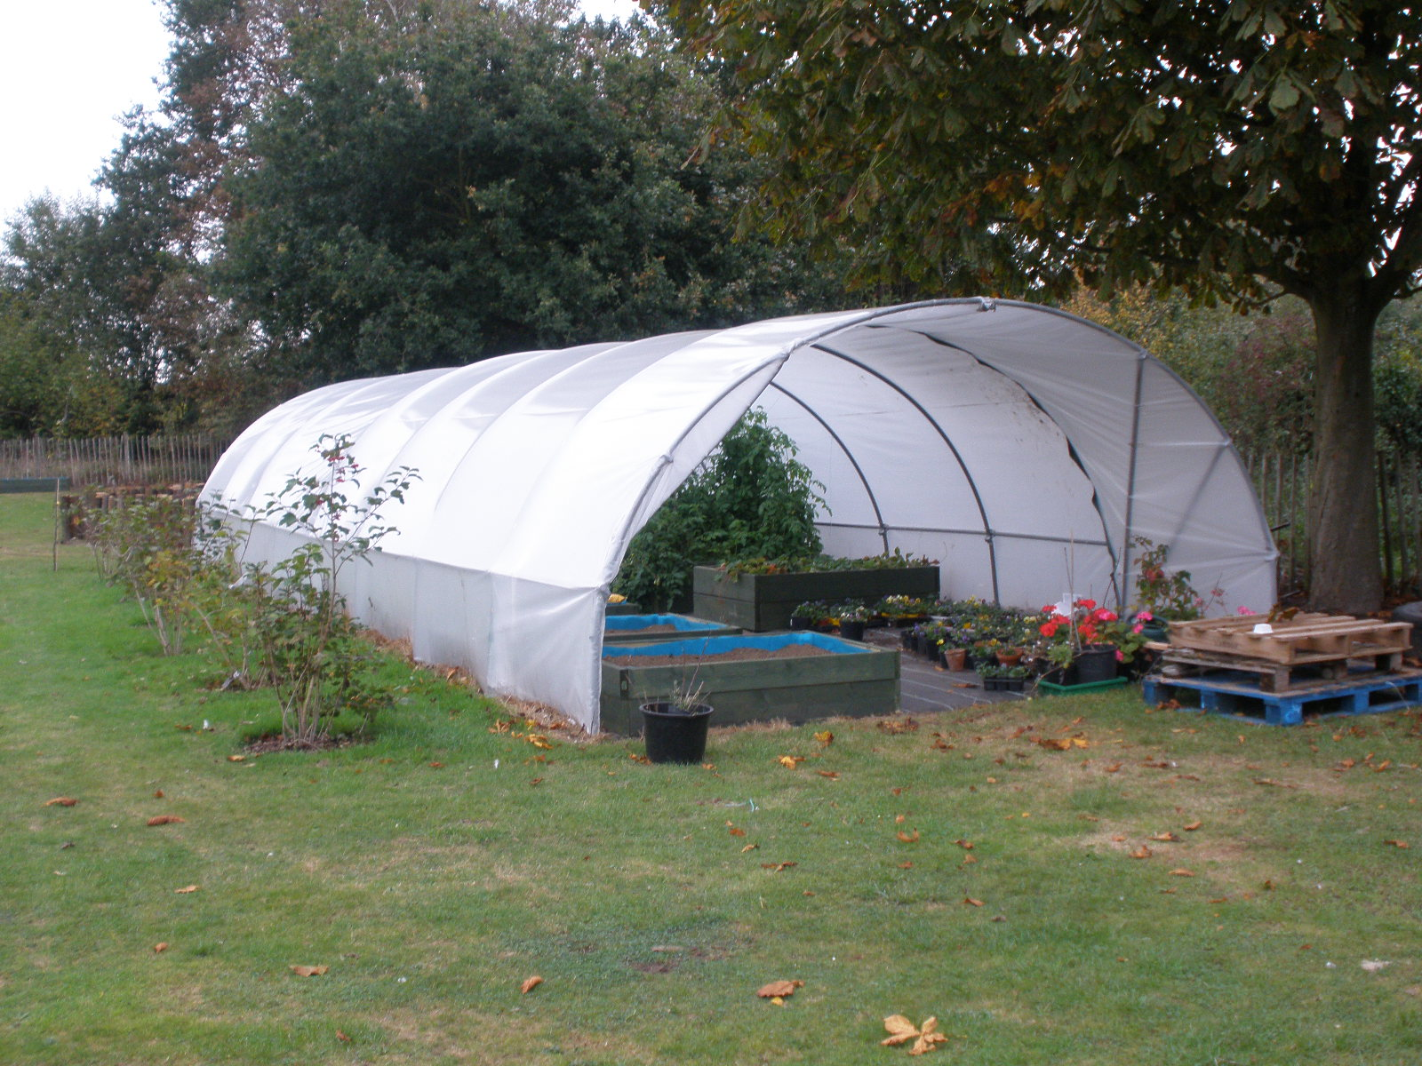

**The poly tunnel in our garden area**

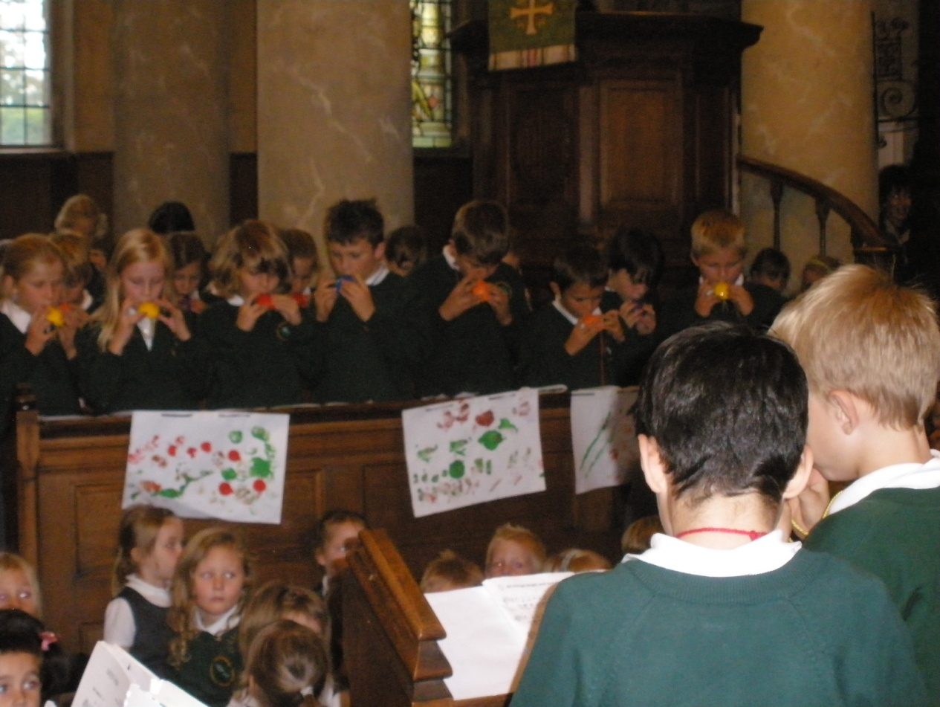

**Playing Ocarinas at the Harvest celebration in the village church**